FULL STACK WEB DEVELOPMENT LAB
Course Project

Mental Health Support Portal

Submitted by
Student Name

PRN
Ashlesha Gawkar 1032232976
Ayan Ahmad 1032232862
Ritisha Kaushik 1032232907

Course Details
- Programme: CSE Year: TY
- Course Name: Full Stack Web Development Lab
- Academic Year: 2025-26
- Semester: 6th

Submitted To
Dr. Sanket Salvi
Faculty, Full Stack Web Development Lab
Date of Synopsis: 20 February 2026
Date of Progress: 19 March 2026
Date of Final Submission:

SECTION I: SYNOPSIS SUBMISSION

Abstract / Project Synopsis
The Mental Health Support Portal is a web-based platform designed to provide accessible and affordable mental health services. Many individuals face challenges such as high therapy costs, lack of awareness, and social stigma, preventing them from seeking help. This project aims to address these issues by offering a centralized platform where users can book therapy sessions, access mental health resources, and provide feedback.
The system integrates therapist appointment booking, educational content, and secure data management. It ensures user privacy while providing a user-friendly interface. The expected outcome is a scalable and efficient platform that improves accessibility to mental health support and encourages individuals to take care of their well-being.

Introduction

The Mental Health Support Portal is designed as a full-stack web application to bridge the gap between individuals and mental health professionals. It provides a centralized platform where users can access therapy services, educational resources, and feedback mechanisms. The system focuses on usability, affordability, and secure data handling.
  - Background and Motivation
Mental health issues like stress, anxiety, and depression are increasing rapidly. However, access to professional help is limited due to cost, lack of availability, and stigma. With the growth of web technologies, there is a need for a digital platform that provides easy access to mental health services.
  - Problem Statement
Many individuals lack access to affordable and reliable mental health support systems. Existing solutions are either costly, not engaging, or lack integration of services. We are providing a web-based solution to bridge this gap.
  - Objectives
To develop a platform for therapist appointment booking
To provide mental health resources
To ensure data security and privacy
To allow feedback and interaction between users and therapists

Literature Review / Related Work
Existing platforms like online therapy apps provide consultation services but often lack affordability and engaging features. Many systems do not integrate booking, resources, and feedback in one place.
The limitation of current systems includes:
High cost of services
Limited accessibility
Lack of integrated features
This project aims to overcome these gaps by providing a unified solution.

Proposed System
  - Proposed Solution
A web-based portal where users can:
Register and log in
Book therapy sessions
Access mental health resources
Provide feedback
  - System Architecture (Proposed)
Flow: User → Frontend → Backend APIs → Database → Response → Frontend
  - Proposed Technology Stack
    - Frontend: HTML, CSS, JavaScript
    - Backend: Node.js, Express.js
    - Database: MySQL
    - Tools / Frameworks: GitHub

Scope of the Project

- Web-based system only
- Focus on booking, resources, and feedback
- No advanced AI-based diagnosis

Expected Outcomes
- Functional web application
- Secure database system
- Easy appointment booking system

7. Project Plan

Week 1–2: Requirement Analysis

Week 3–4: Design (ER Diagram, UI)

Week 5–7: Development

Week 8: Testing and Deployment

SECTION II: PROGRESS EVALUATION

System Overview (Revised)
The Mental Health Support Portal has been implemented as a responsive web application with a clean and intuitive interface, allowing users to easily navigate through features such as registration, login, and service exploration. The system provides core functionalities including access to professional therapy services, appointment scheduling, session history tracking, and secure user data handling.

Requirement Analysis
  - Functional Requirements
- User registration/login
- Therapist profile management
- Appointment booking
- Payment handling
- Feedback system
  - Non-Functional Requirements

- Security (password hashing)

- Performance (fast response time)

- Usability (simple UI)

- Scalability

System Design
  - Use Case Diagram
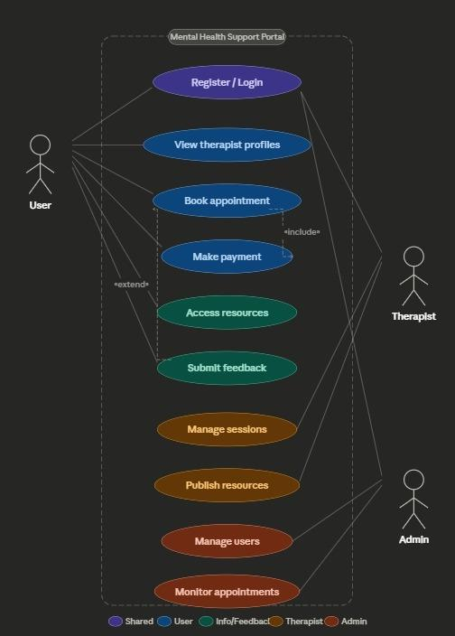
Description of actors and use cases.
  - Data Flow Diagram (DFD)
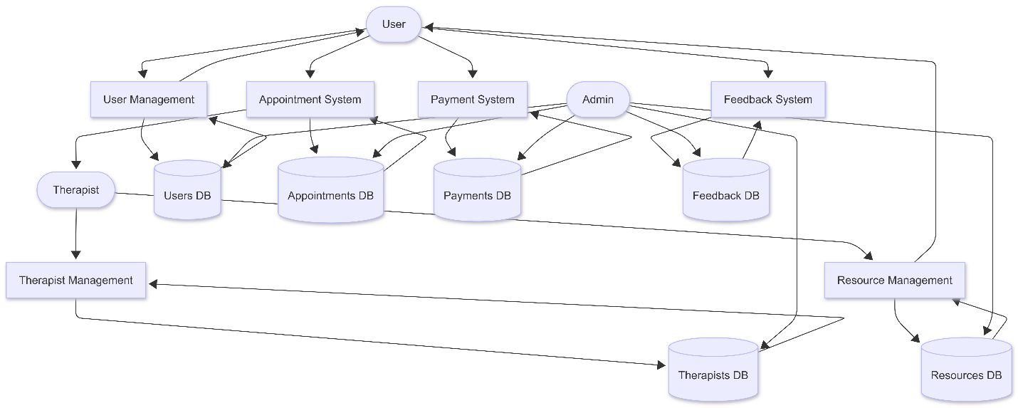

Module-wise Data Flow
1️⃣ User Management
- User → User Management
- Data sent: registration details, login credentials
- Stored in → Users DB
- Used by:
  - Appointment System (to identify user)
  - Payment System (for billing)
👉 This module handles authentication and user profile data.

2️⃣ Therapist Management
- Therapist → Therapist Management
- Data: profile, specialization, experience
- Stored in → Therapists DB
- Used by:
  - Appointment System (for booking)
  - Resource Management (content creator)
👉 Therapist data becomes available system-wide.

3️⃣ Appointment System
- User → searches therapist → books appointment
- Reads:
  - Users DB
  - Therapists DB
- Writes:
  - Appointments DB
- Sends data to:
  - Therapist (appointment details)
  - Payment System (for payment)
👉 Acts as the core interaction module.

4️⃣ Payment System
- User → makes payment
- Input from:
  - Appointment System
- Stores:
  - Payment info in Payments DB
- Updates:
  - Appointment status (paid)
👉 Handles financial transactions and updates booking status.

5️⃣ Feedback System
- User → gives feedback after session
- Input from:
  - Appointment System (completed session)
- Stores:
  - Feedback in Feedback DB
- Accessed by:
  - Admin (monitor quality)
👉 Ensures service evaluation and improvement.

6️⃣ Resource Management
- Therapist → uploads resources
- User → views resources
- Stored in → Resources DB
- Linked with:
  - Therapist (creator)
👉 Provides educational and mental health content.

7️⃣ Admin Flow (Very Important ⭐)
- Admin interacts with:
  - Users DB
  - Therapists DB
  - Appointments DB
  - Payments DB
  - Feedback DB
- Functions:
  - Monitoring
  - Managing users/therapists
  - Checking payments & feedback
👉 Admin has overall system control.

🔗 Cross-Module Flow
🔹 Key Connections:
- User Management → Appointment System
- Appointment System → Payment System
- Appointment System → Feedback System
- Therapist Management → Resource Management
- All modules → Admin

  - Database Design
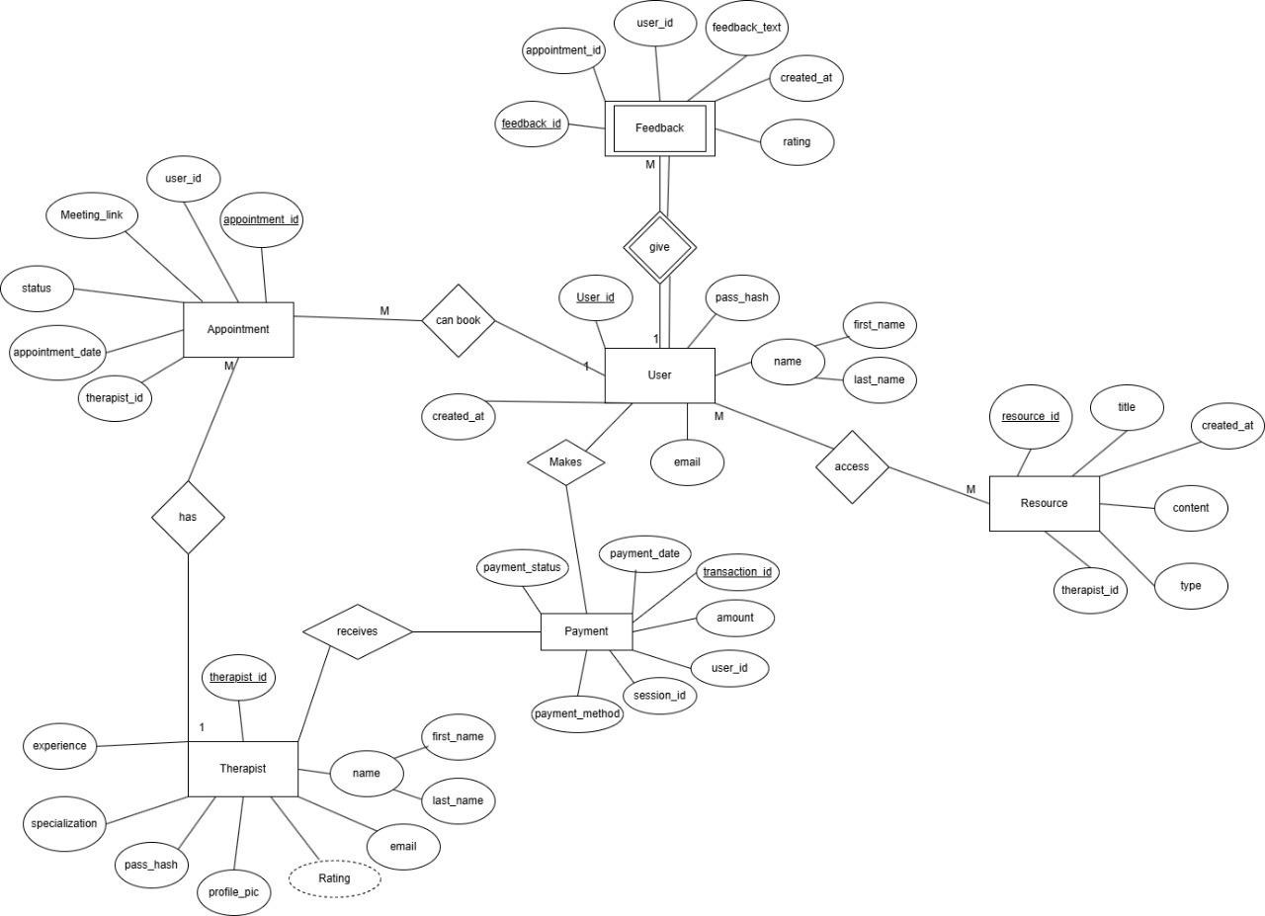
Schemas
- Users (UserID, Name, Email, Phone, Password )
- Therapists (TherapistID, Name, Email, Phone, Specialization, Experience, ProfilePic, Password)
- Appointments (AppointmentID, UserID, TherapistID, AppointmentDate, Status, MeetingLink )
- Payments (PaymentID, UserID, Amount, PaymentDate)
- Feedback (FeedbackID, UserID, AppointmentID, Rating, FeedbackText, CreatedAt )
- Resources (ResourceID, TherapistID, Title, Content, Type, CreatedAt )

Implementation Status

The Mental Health Support Portal is implemented as a client–server web application where the frontend, running on localhost:3000, delivers a responsive UI with routing for Home, Login, and Registration pages, while dynamically rendering components such as service listings and call-to-action sections. The backend, built using Node.js and Express.js, handles RESTful API requests for user authentication, therapist data retrieval, and appointment workflows. The system supports modular features including therapist discovery, session scheduling, session history tracking, and secure data handling, with all persistent data managed through a MySQL relational database. The architecture ensures separation of concerns, enabling efficient communication between frontend and backend while maintaining scalability and maintainability for future feature integration.
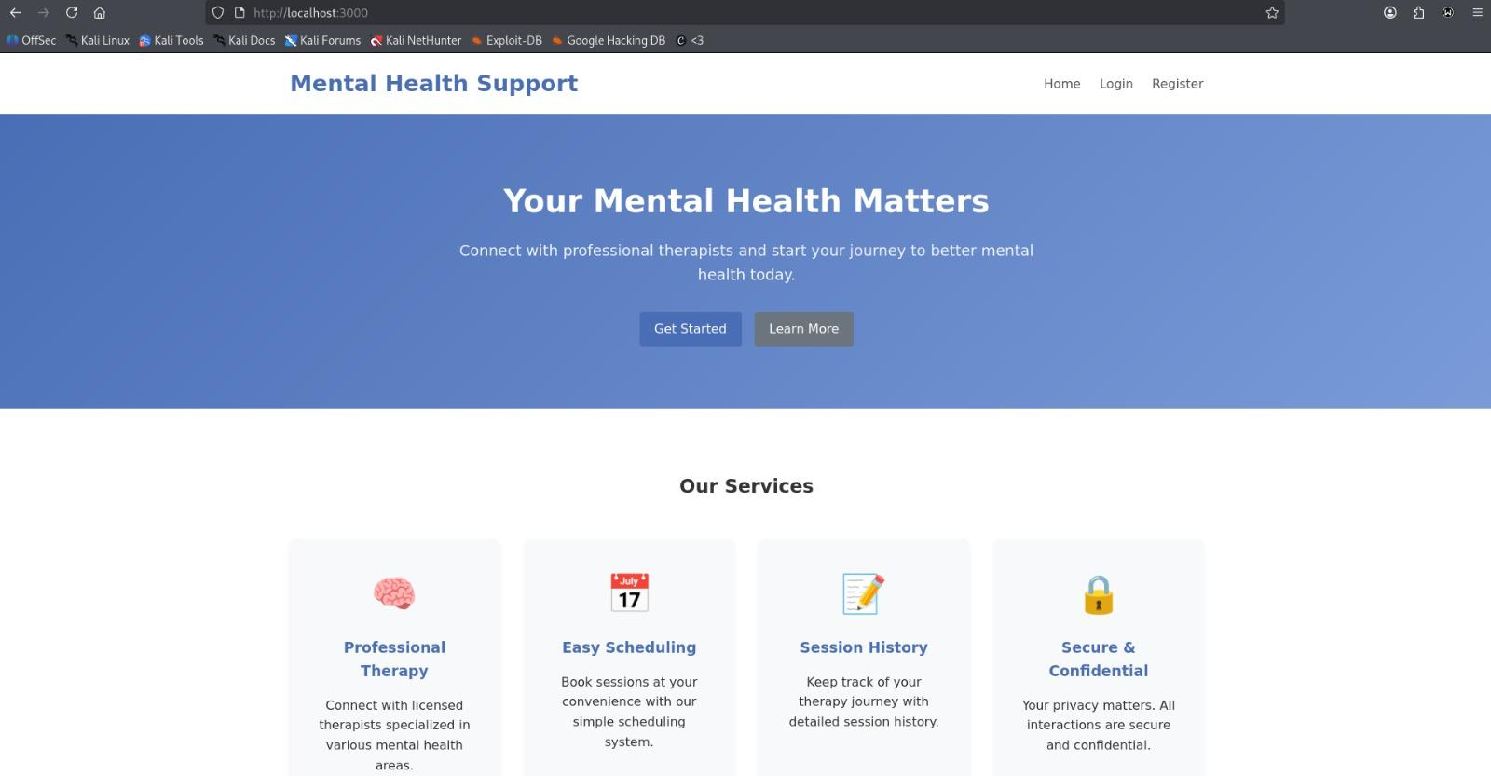

SECTION III: FINAL SUBMISSION

Final System Description
Complete description of the fully implemented system.

Implementation Details
  - Frontend Implementation
Final UI design, workflows, and validation.
  - Backend Implementation
Final API design, business logic, and integrations.
  - Database Implementation
Final schema and data handling.

Testing
  - Test Plan
Testing strategy and tools.
  - Test Cases and Results
Tabulated test cases with expected and actual results.

Results and Discussion
Final outputs, screenshots, performance analysis, and discussion.

Deployment
Deployment environment, hosting platform, and configuration details.

Conclusion
Summary of work completed and learning outcomes.

Future Scope
Possible enhancements and future extensions.

References
References formatted in IEEE / APA style.

Appendix (Optional)
Source code snippets, additional screenshots, user manual, etc.

